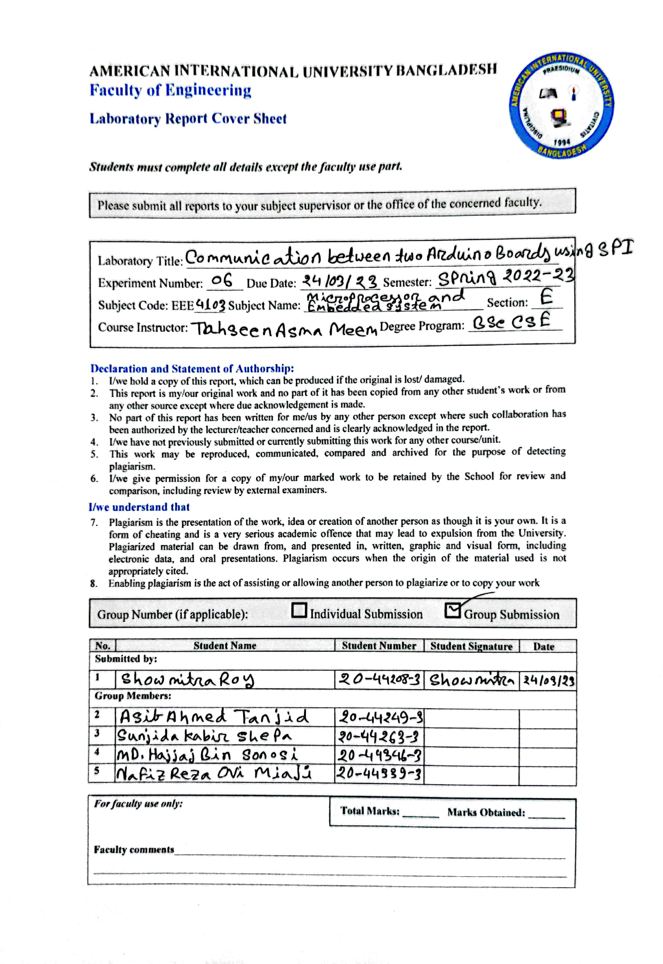





**Source Code:**

**Master/Controller Arduino Code:**

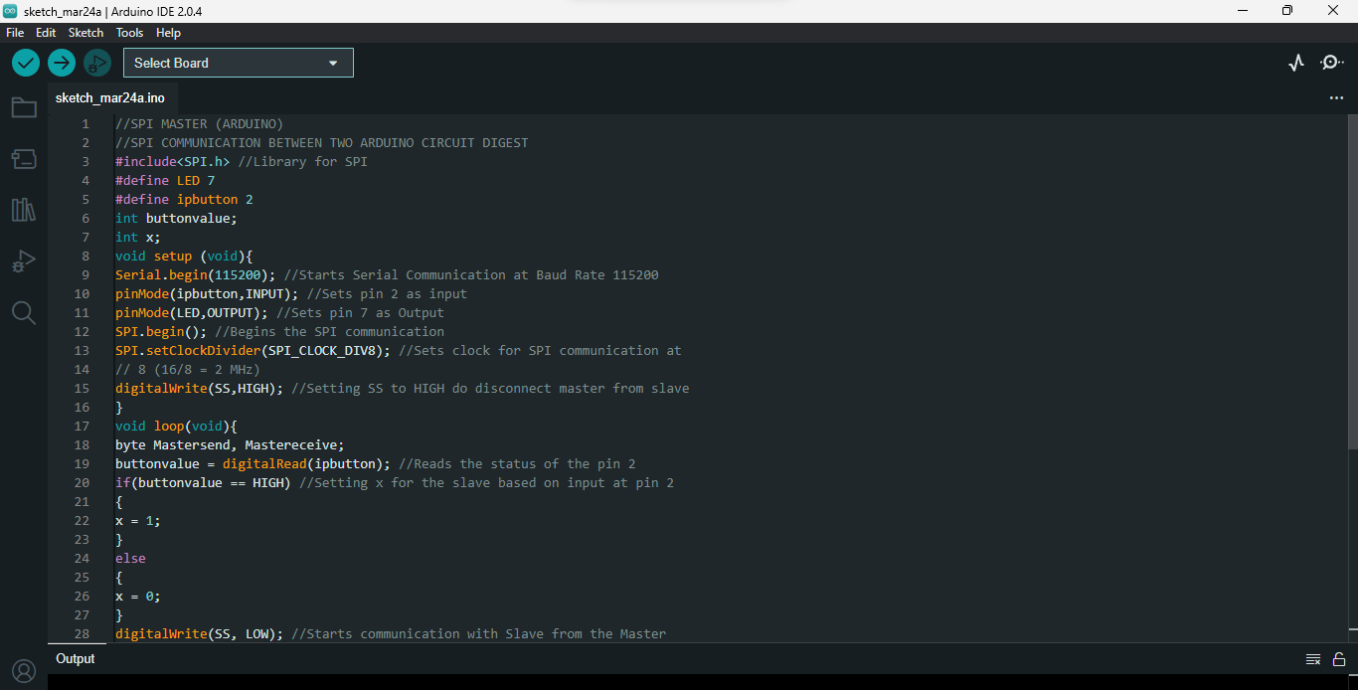

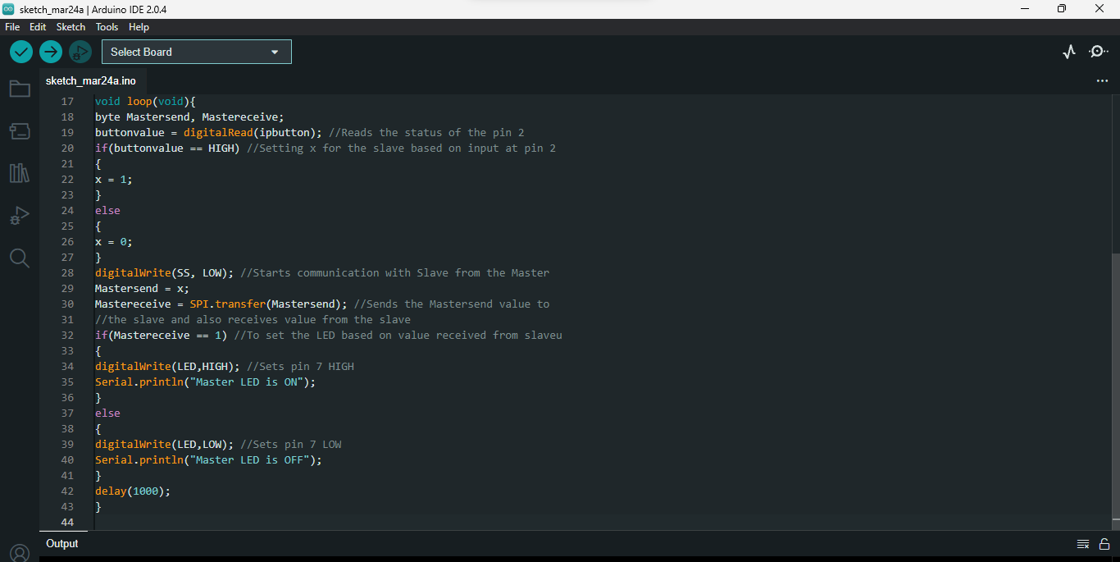

**Figure: Master/Controller Arduino Code**

**Slave/Peripheral Arduino Code:**

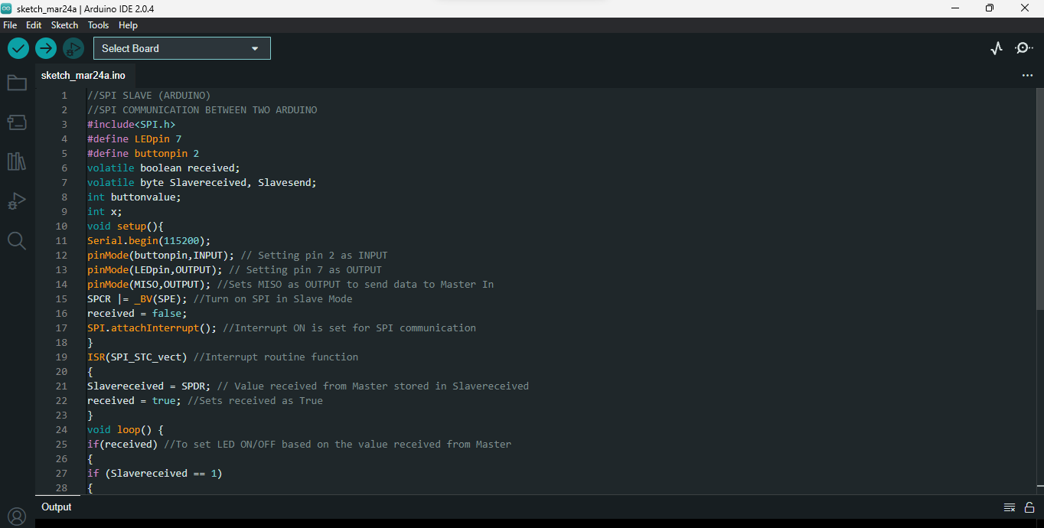 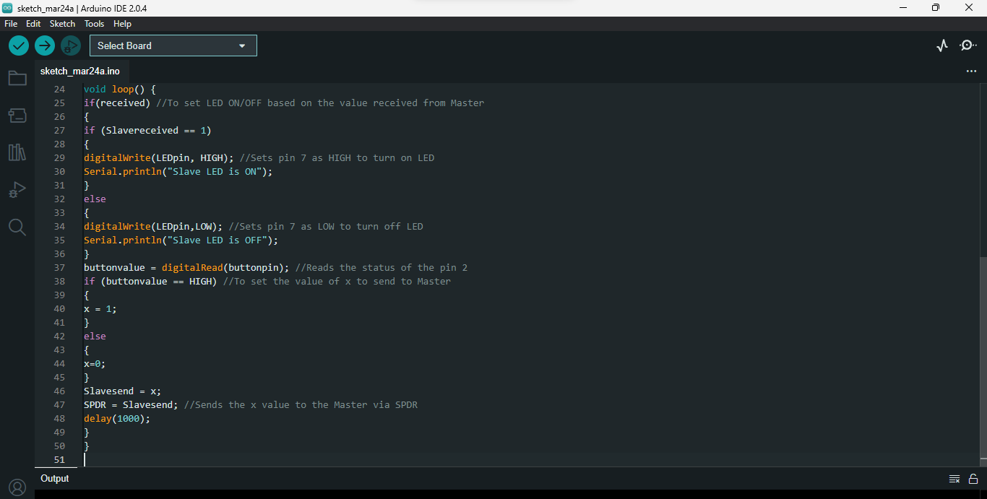

**Figure: Slave/Peripheral Arduino Code:**

**Simulation:**

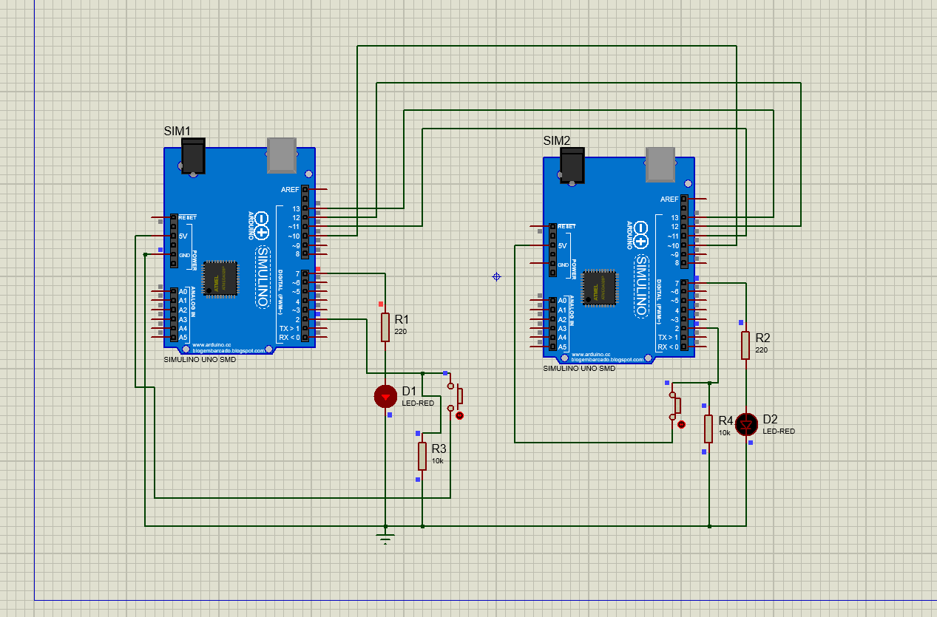

Figure: Two Arduino board’s pin connections for SPI communications

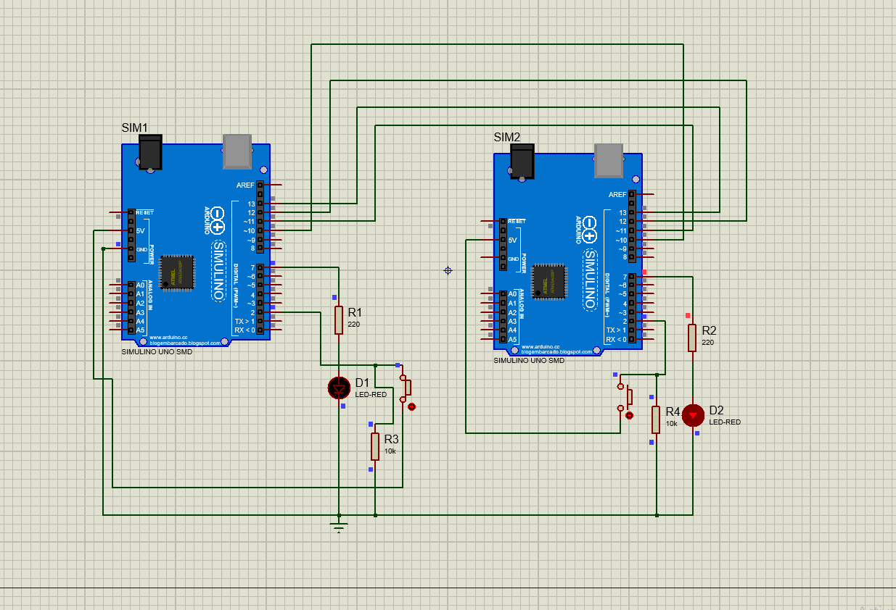

Figure: Two Arduino board’s pin connections for SPI communications

**Lab Simulation:**

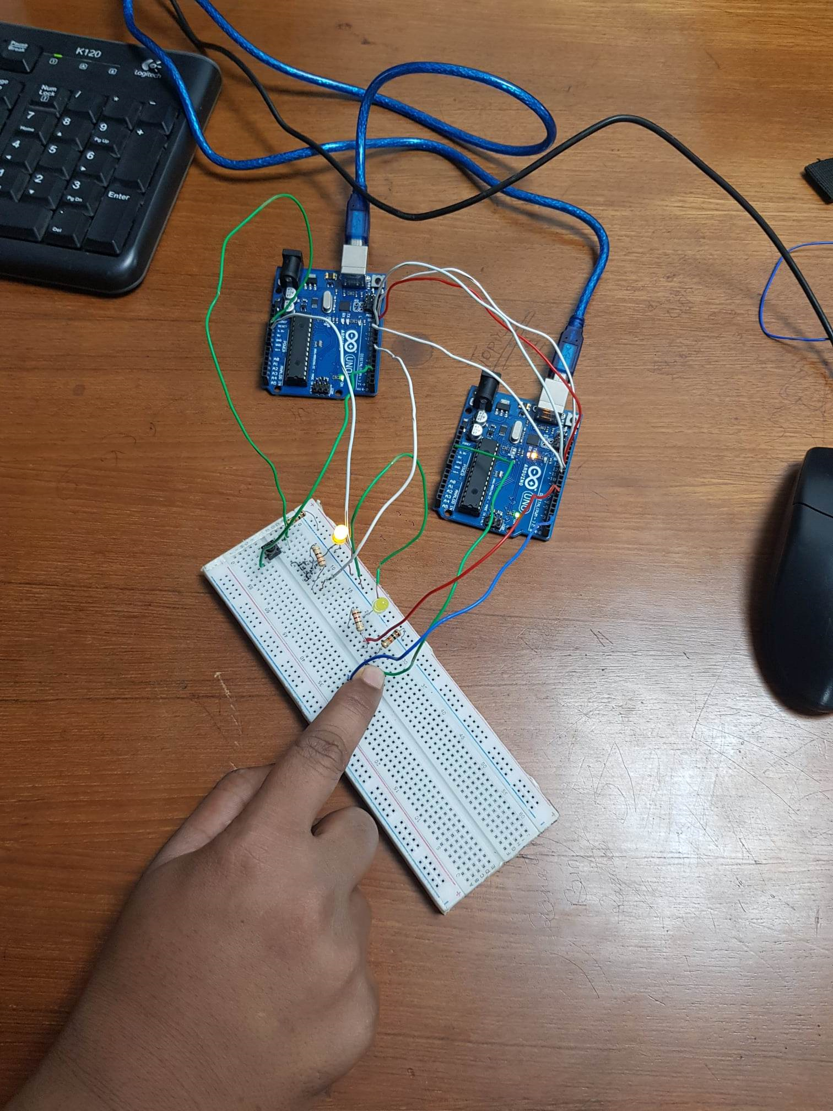

Figure: Two Arduino board’s pin connections for SPI communications

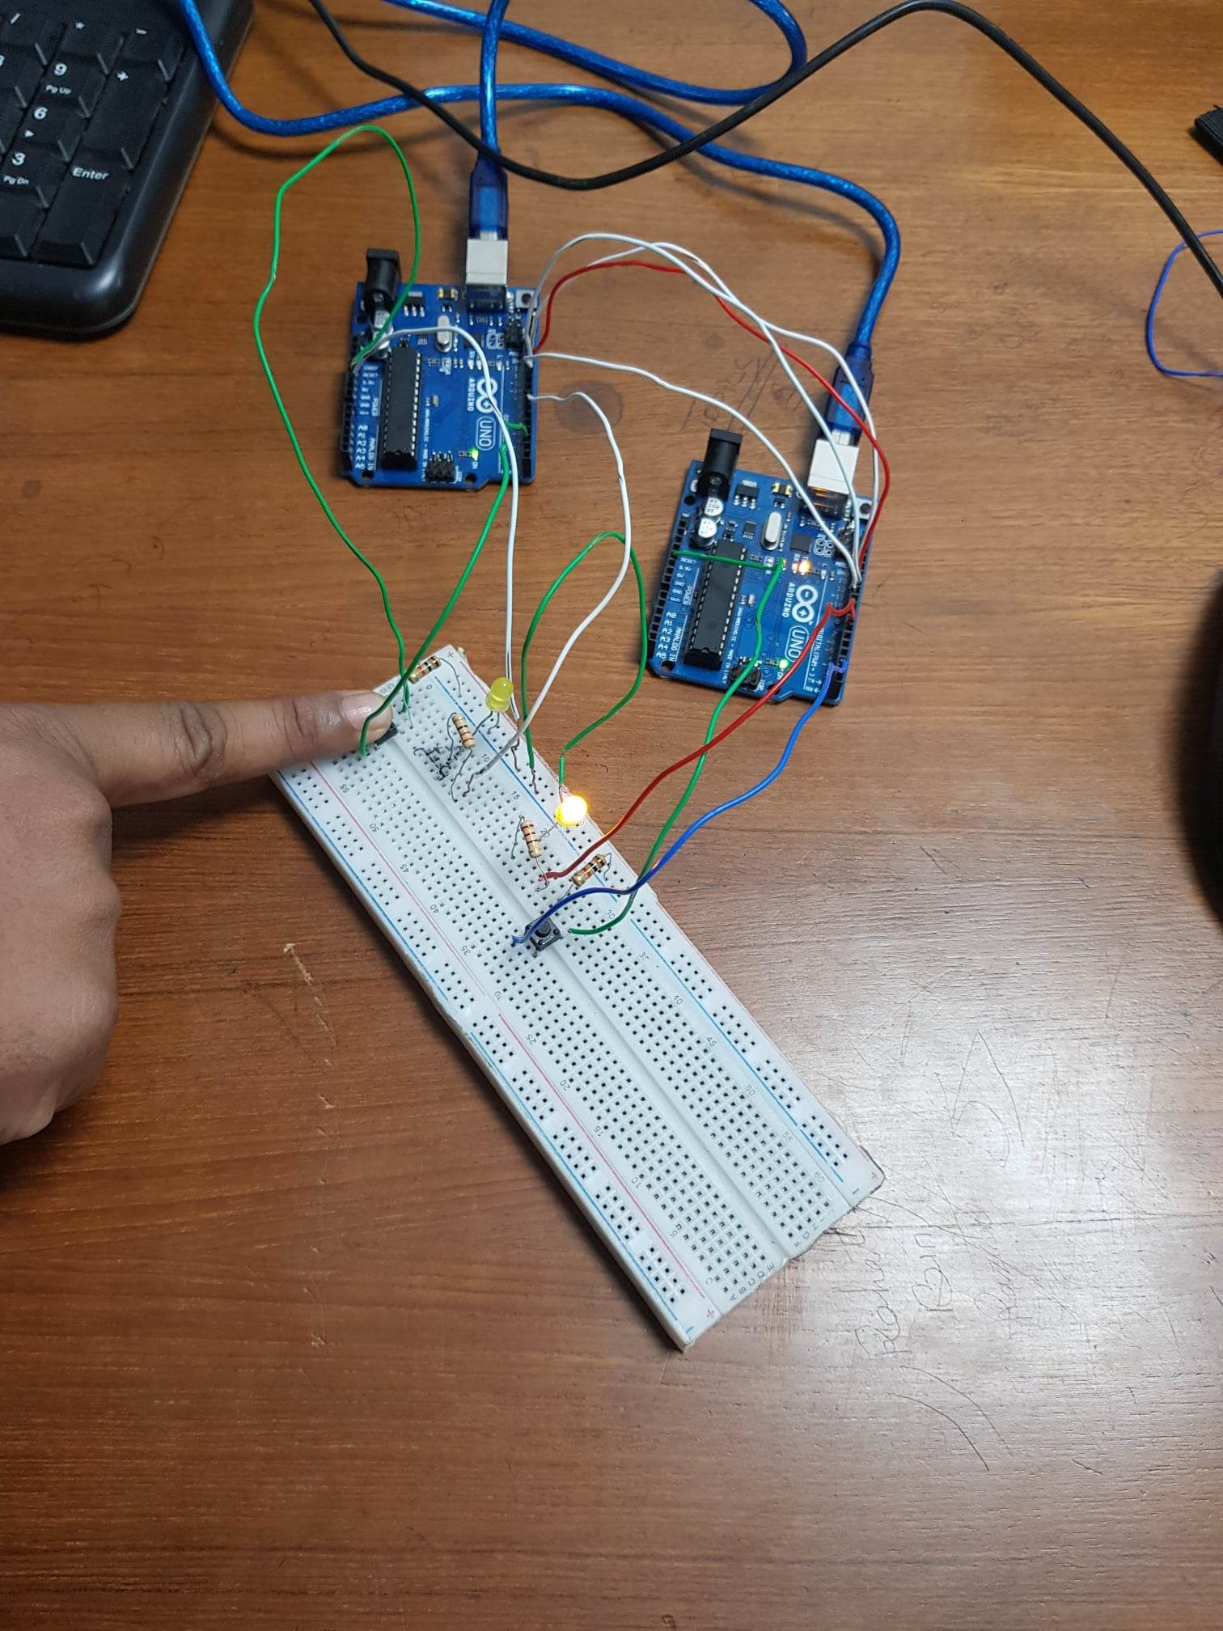

Figure: Two Arduino board’s pin connections for SPI communications

**Report:**

All codes, scripts and proteus simulation of the blink program and traffic light system is attached above.



